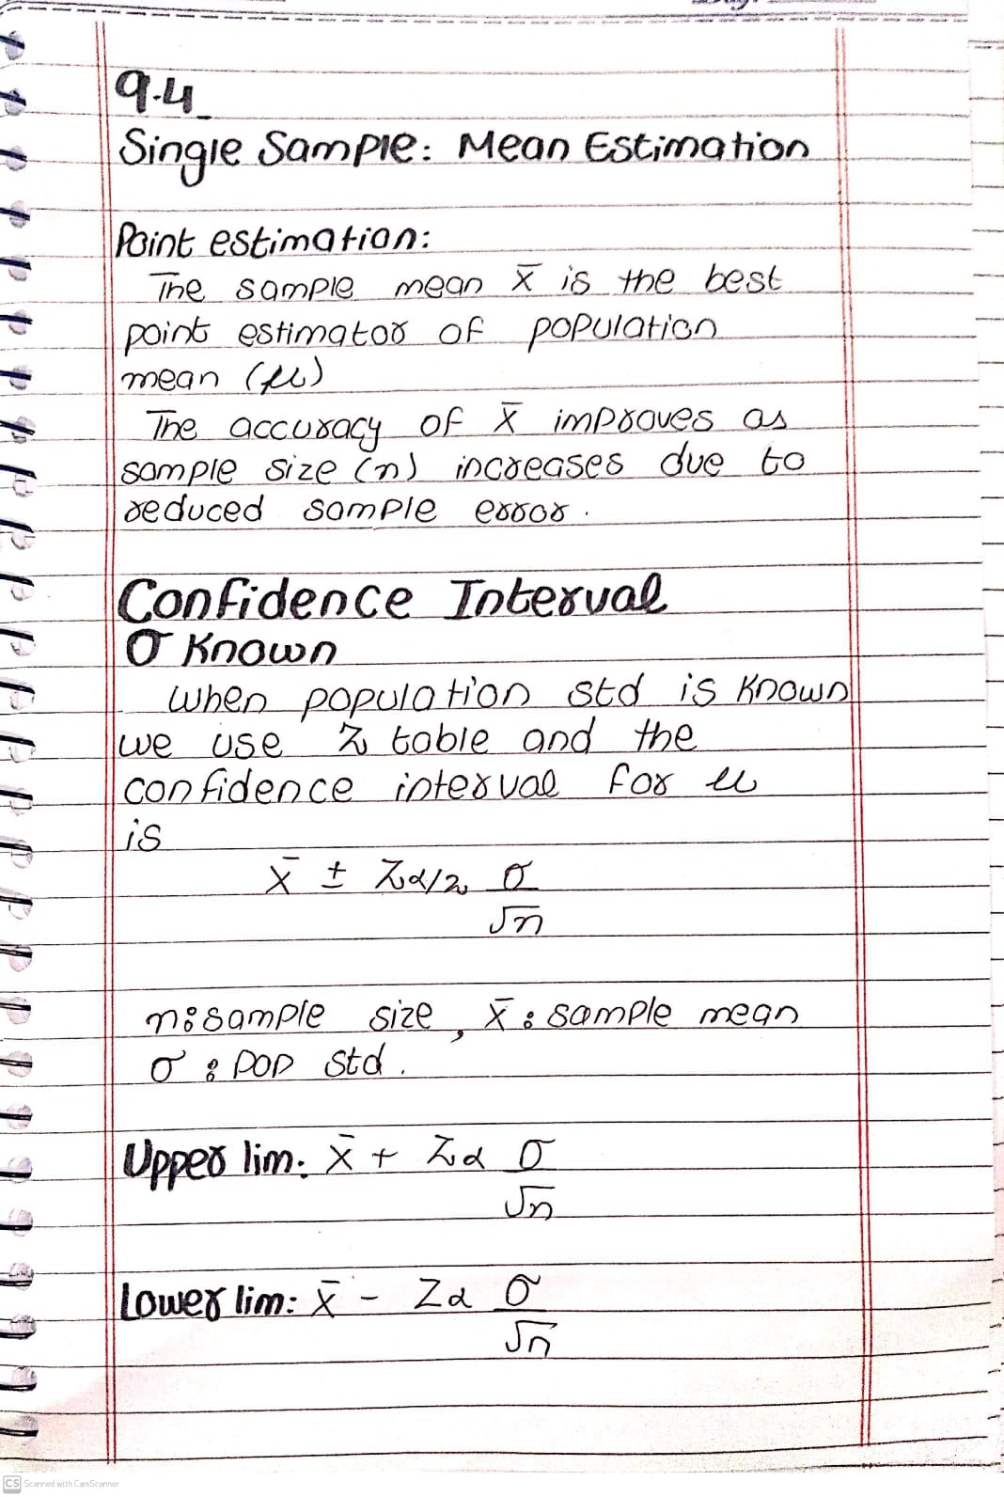
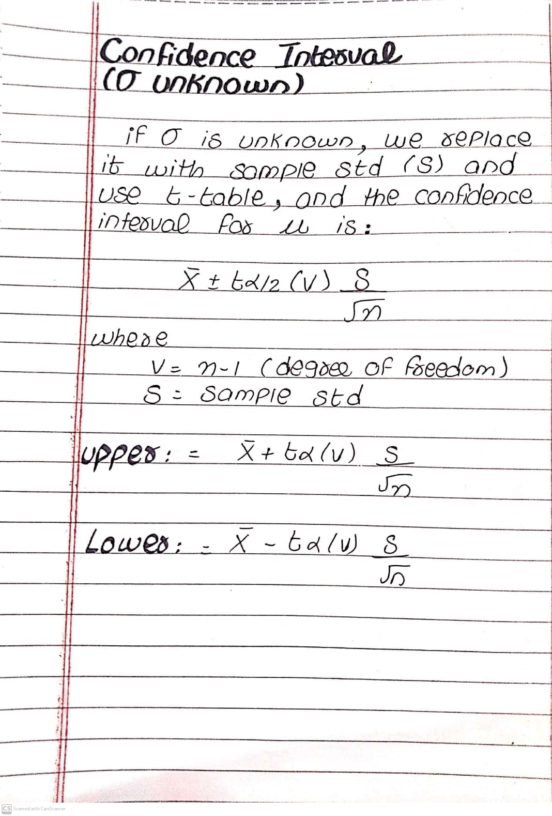

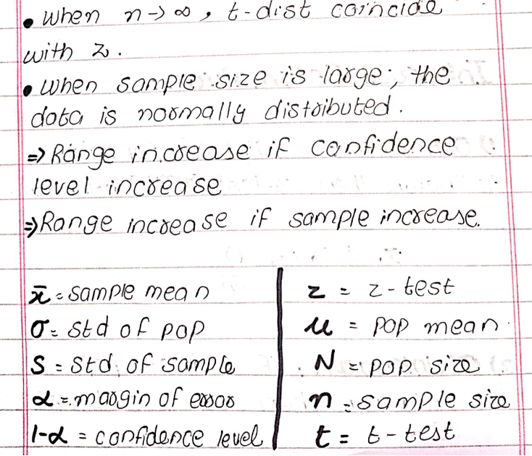

Practice questions:
In a psychological testing experiment, 25 subjects are selected randomly and their reaction time, in seconds, to a particular stimulus is measured. Past experience suggests that the variance in reaction times to these types of stimuli is 4 sec2 and that the distribution of reaction times is approximately normal. The average time for the subjects is 6.2 seconds. Give an upper 95% bound for the mean reaction time.
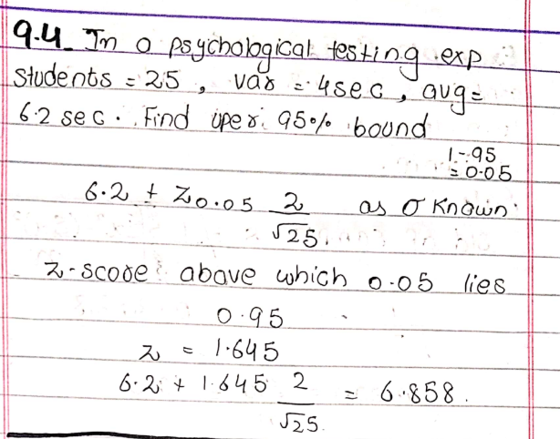

Practice Question:
The average zinc concentration recovered from a sample of measurements taken in 36 different locations in a river is found to be 2.6 grams per milliliter. Find the 95% and 99% confidence intervals for the mean zinc concentration in the river. Assume that the population standard deviation is 0.3 gram per milliliter.
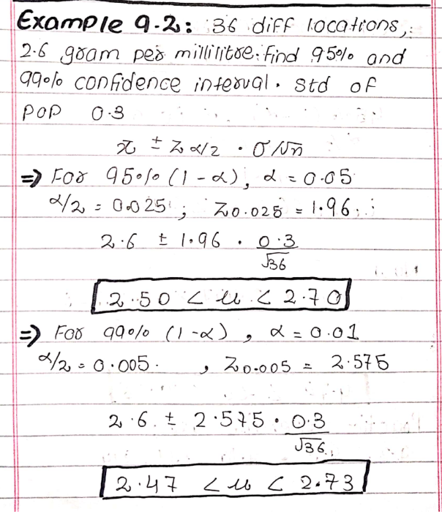

Practice Question:
The contents of seven similar containers of sulfuric acid are 9.8, 10.2, 10.4, 9.8, 10.0, 10.2, and 9.6 liters. Find a 95% confidence interval for the mean contents of all such containers, assuming an approximately normal distribution

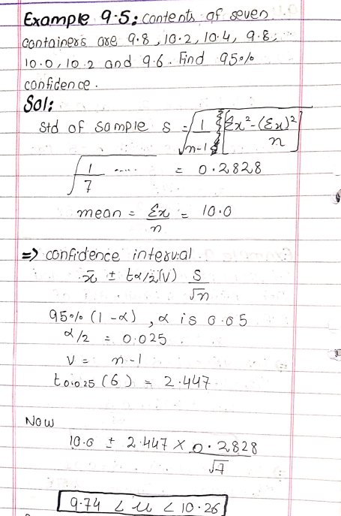

Question:
A town consists of 250 families, and a random sample of 40 families is surveyed. The mean annual church contribution for the sample is $450, and the standard deviation is $75.

a) Find the best estimate of the population mean.

b) Construct a 90% confidence interval for the population mean.

c) Interpret the confidence interval.
